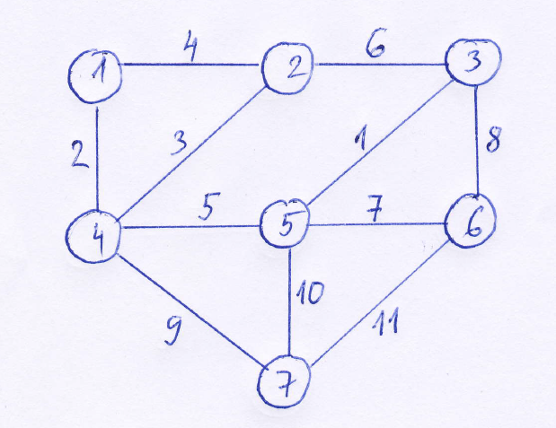

|  |  |
| --- | --- |
| 5 3 1 | да |
| 1 4 2 | да |
| 4 2 3 | да |
| 1 2 4 | не |
| 4 5 5 | да |
| 2 3 6 | не |
| 5 6 7 | да |
| 3 6 8 | не |
| 4 7 9 | да |
| 5 7 10 | не |
| 6 7 11 | не |

|  |  |  |  |  |  |  |
| --- | --- | --- | --- | --- | --- | --- |
| 1 | 2 | 3 | 4 | 5 | 6 | 7 |
| 1 | 1 | 1 | 1 | 1 | 1 | 1 |

v-w weight  
 -----------  
 A-F 12  
 A-B 8  
 A-G 7  
 C-B 16  
 B-H 15  
 B-G 10  
 C-D 9  
 H-C 4  
 E-D 11  
 D-I 5  
 H-D 3  
 D-J 2  
 J-E 14  
 F-G 13  
 G-H 17  
 I-H 6  
 I-J 1  
  
 (A)------8------(B)------16-----(C)------9------(D)------11-----(E)  
 |\ |\ | /|\ |   
 | \ | \ | / | \ |   
 | \ | \ | / | \ |   
 | \ | \ | / | \ |   
 | \ | \ | / | \ |   
 | \ | \ | / | \ |   
 | \ | \ | / | \ |   
 12 7 10 15 4 3 5 2 14  
 | \ | \ | / | \ |   
 | \ | \ | / | \ |   
 | \ | \ | / | \ |   
 | \ | \ | / | \ |   
 | \ | \ | / | \ |   
 | \ | \ | / | \ |   
 | \| \|/ | \|   
 (F)------13-----(G)------17-----(H)------6------(I)------1------(J)

v-w weight action  
--------------------------------------------------------------------  
I-J 1 add to MST Minimum Spanning Tree  
D-J 2 add to MST  
H-D 3 add to MST  
H-C 4 add to MST  
D-I 5 discard (adding to MST would create cycle I-D-J-I)  
I-H 6 discard (adding to MST would create cycle H-I-J-D-H)  
A-G 7 add to MST  
A-B 8 add to MST  
C-D 9 discard (adding to MST would create cycle D-C-H-D)  
B-G 10 discard (adding to MST would create cycle G-B-A-G)  
E-D 11 add to MST  
A-F 12 add to MST  
F-G 13 discard (adding to MST would create cycle G-F-A-G)  
J-E 14 discard (adding to MST would create cycle E-J-D-E)  
B-H 15 add to MST

|  |  |  |  |  |  |  |  |  |  |  |  |
| --- | --- | --- | --- | --- | --- | --- | --- | --- | --- | --- | --- |
| A | B | C | D | E | F | G | H | I | J | ребро | x |
| A | B | C | D | E | F | G | H | I | J | I-J | 1 |
| A | B | C | D | E | F | G | H | I | I | D-J | 2 |
| A | B | C | D | E | F | G | H | D | D | H-D | 3 |
| A | B | C | H | E | F | G | H | H | H | H-C | 4 |
| A | B | H | H | E | F | G | H | H | H | A-G | 7 |
| A | B | H | H | E | F | A | H | H | H | A-B | 8 |
| A | A | H | H | E | F | A | H | H | H | E-D | 11 |
| A | A | E | E | E | F | A | E | E | E | A-F | 12 |
| F | F | E | E | E | F | F | E | E | E | B-H | 15 |
| F | F | F | F | F | F | F | F | F | F |  |  |

Here is a graphical representation of the MST:  
  
 (A)------8------(B) (C) (D)------11-----(E)  
 |\ \ | / \   
 | \ \ | / \   
 | \ \ | / \   
 | \ \ | / \   
 | \ \ | / \   
 | \ \ | / \   
 | \ \ | / \   
 12 7 15 4 3 2   
 | \ \ | / \   
 | \ \ | / \   
 | \ \ | / \   
 | \ \ | / \   
 | \ \ | / \   
 | \ \ | / \   
 | \ \|/ \   
 (F) (G) (H) (I)------1------(J)